By Gijs Winkelhorst and Sven Kerkhof
risico analyse
Project gear deburr

Foreword
This risk analysis report has been prepared as part of our Gear Deburring Project, aiming to systematically identify, evaluate, and mitigate potential hazards associated with the design, operation, and maintenance of the system. The purpose of this analysis is to ensure the safety of personnel, protect equipment, and maintain a high standard of process reliability.
Throughout this project, we have considered mechanical, electrical, and operational risks, integrating both theoretical knowledge and practical insights gained during the development phase. By documenting potential risks and their corresponding control measures, this report serves as a foundation for informed decision-making and continuous improvement.
We hope that this analysis not only highlights the importance of safety and risk management in engineering projects but also provides clear guidance for future developments in automated gear deburring systems.

Inhoud
Foreword 1
hand in the wire brush before measures have been taken 3
hand in the wire brush after measures have been taken 3
Hand under pneumatic cylinder before measures have been taken 5
Hand under pneumatic cylinder after measures have been taken 6
Debris from gear hitting operator before measures have been taken 7
Debris from gear hitting operator after measures have been taken 8
Wires flying from steel brush before measures have been taken 9
Wires flying from steel brush after measures have been taken 10

hand in the wire brush before measures have been taken
It is very easy to get your hand caught in the wire brush if you are not paying attention, for example when you want to position the gear wheel correctly on the turntable or because you want to feel whether the burrs have actually disappeared. If the wire brush starts up, you can suffer some really nasty injuries. With a bit of bad luck, you could lose a large piece of skin from your hand.
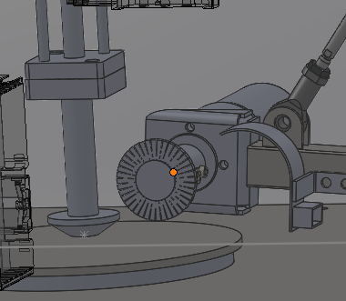
 | punten
blootstelling | 2
waarschijnlijkheid | 2,5
mogelijkheid | 2,5
ernst | 3
risicoklasse | 37,5

hand in the wire brush after measures have been taken
To prevent you from getting your hand caught in the wire brush, we have shielded the entire machine with steel plating. This makes it much more difficult to reach the wire brush with your hand. At the front of our machine, there is an inlet covered with rubber strips. You can still reach inside with your hand, but you have to do so deliberately. There is also a small protective cap around the wire brush, which provides additional protection.
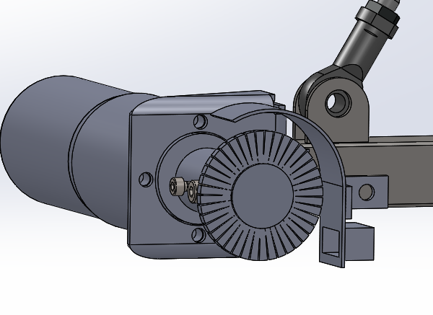
Figure 1 protective cap around wire brush
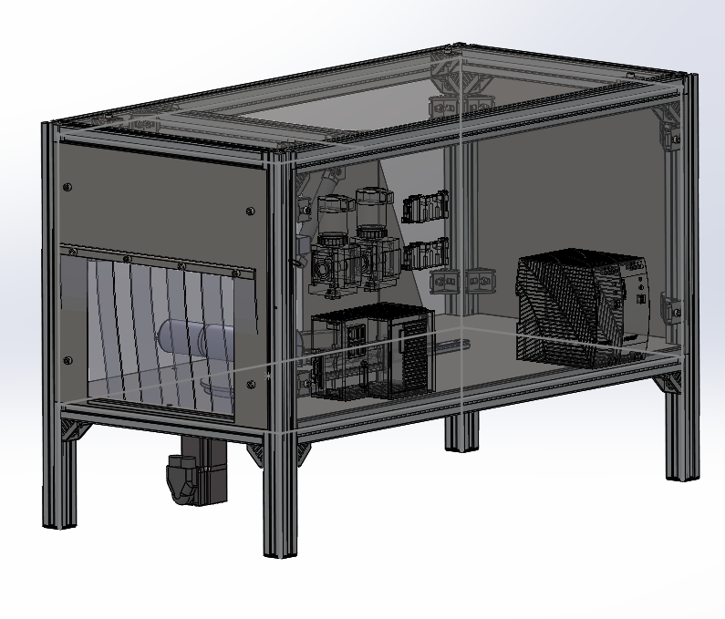
Figure 2 plating around the machine

 | punten
blootstelling | 2
waarschijnlijkheid | 1,25
mogelijkheid | 1
ernst | 4
risicoklasse | 10
The risk class number now shows that the risk is acceptable after the measures have been taken.
Hand under pneumatic cylinder before measures have been taken
The user can easily put their hand into the machine and get it under the pneumatic cylinder. If they have their hand under the pneumatic cylinder and the cylinder goes down, this is not very pleasant. Depending on the set pressure and speed of the cylinder, this could cause bruising to the hand.
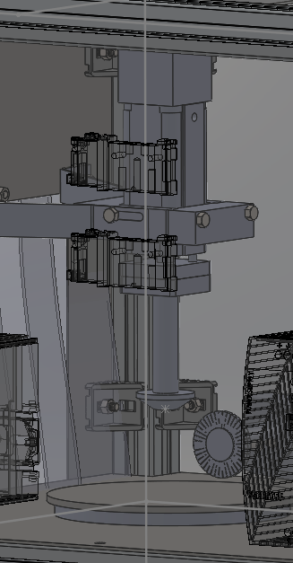
Figure 3 cilinder is up
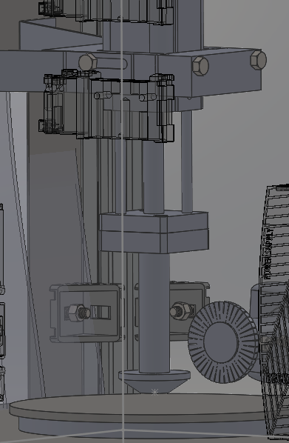
Figure 4 cilinder is down
 | punten
blootstelling | 2
waarschijnlijkheid | 2,5
mogelijkheid | 2,5
ernst | 3
risicoklasse | 37,5

Hand under pneumatic cylinder after measures have been taken
The user can easily put their hand into the machine and get it under the pneumatic cylinder. If they have their hand under the pneumatic cylinder and the cylinder goes down, this is not very pleasant. Depending on the set pressure and speed of the cylinder, this could cause bruising to the hand.
To reduce this risk, we have fitted steel plating around the machine so that the user cannot easily put their hand into the machine. The intention is to install a light sensor at the front of the machine. If someone does put their hand in at the front, the light sensor will be activated and the machine will not start up.
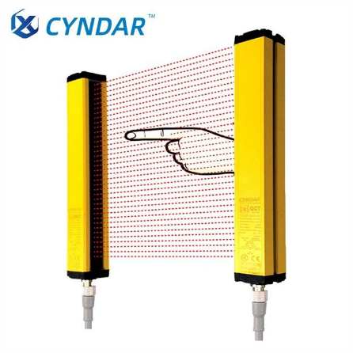
Figure 5 lightbeam barrier
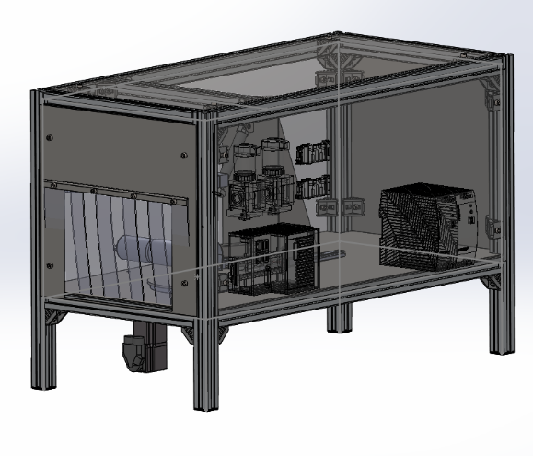
Figure 6 plating around machine
 | punten
blootstelling | 2
waarschijnlijkheid | 1,25
mogelijkheid | 1
ernst | 3
risicoklasse | 7,5
The risk class number now shows that the risk is acceptable after the measures have been taken.

Debris from gear hitting operator before measures have been taken
When the machine is deburring a gear, burrs that have come loose from the gear can fly around. If the user is standing close to the machine, loose burrs can hit them or even get into their eyes. If a burr hits your eye at high speed, it can cause serious damage. In the worst case, you could even go blind.
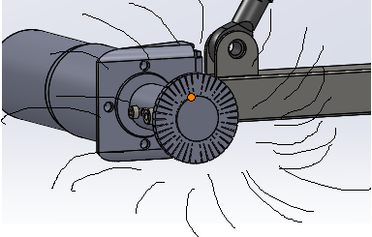
Figure 7 debris flying around
 | punten
blootstelling | 3
waarschijnlijkheid | 6
mogelijkheid | 2,5
ernst | 4
risicoklasse | 180

Debris from gear hitting operator after measures have been taken
When the machine is deburring a gear, burrs that have come loose from the gear can fly around. If the user is standing close to the machine, loose burrs can hit them or even get into their eyes. If a burr hits your eye at high speed, it can cause serious damage. In the worst case, you could even go blind.
To prevent loose burrs from flying out of the machine, we have fitted plating around the machine and created an extra protective cover around the steel brush, which works on the same principle as a grinder. We have also fitted a connection to this protective cover to which a vacuum cleaner can be connected, so that most burrs can be sucked up and removed immediately during brushing.

Figure 8 plating around machine
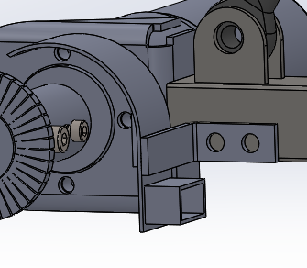
Figure 9 protective cover with vacuum cleaner port
 | punten
blootstelling | 2
waarschijnlijkheid | 0,5
mogelijkheid | 2,5
ernst | 4
risicoklasse | 10
The risk class number now shows that the risk is acceptable after the measures have been taken.
Wires flying from steel brush before measures have been taken
When the machine is deburring a gear, hairs can come loose from the steel brush and fly around. This is actually a bit like the burrs that can fly around. If you get one of these hairs in your eyes, you could go blind in the worst case scenario.

Figure 10 loose wires flying from steelbrush
 | punten
blootstelling | 2
waarschijnlijkheid | 6
mogelijkheid | 2,5
ernst | 4
risicoklasse | 120

Wires flying from steel brush after measures have been taken
When the machine is deburring a gear, hairs can come loose from the steel brush and fly around. This is actually a bit like the burrs that can fly around. If you get one of these hairs in your eyes, you could go blind in the worst case scenario.
To prevent loose wires from flying out of the machine, we have fitted plating around the machine and created an extra protective cover around the steel brush, which works on the same principle as a grinder. We have also fitted a connection to this protective cover to which a vacuum cleaner can be connected, so that most wires can be sucked up and removed immediately during brushing.

Figure 11 plating around machine

Figure 12 protective cap with vacuum port

 | punten
blootstelling | 2
waarschijnlijkheid | 0,5
mogelijkheid | 2,5
ernst | 4
risicoklasse | 10
The risk class number now shows that the risk is acceptable after the measures have been taken.

